CE-1

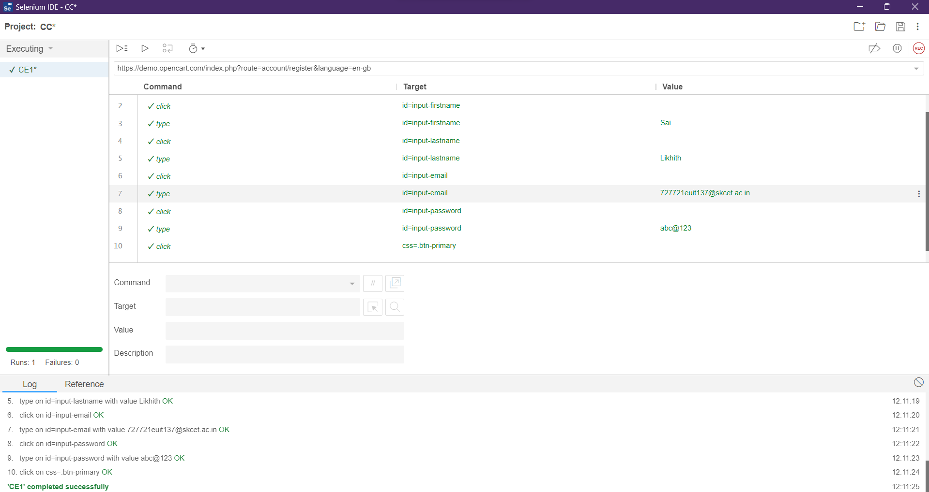

CE-2

package com.testing.demo;

import org.openqa.selenium.By;

import org.openqa.selenium.WebDriver;

import org.openqa.selenium.WebElement;

import org.openqa.selenium.chrome.ChromeDriver;

import io.github.bonigarcia.wdm.WebDriverManager;

public class App

{

public static void main( String[] args )

{

WebDriverManager.chromedriver().setup();

WebDriver driver=new ChromeDriver();

driver.get("https://demo.opencart.com/index.php?route=account/register&language=en-gb");

driver.manage().window().maximize();

WebElement fname= driver.findElement(By.id("input-firstname"));

fname.sendKeys("SaiLikhith");

WebElement lname=driver.findElement(By.xpath("//input[@id=\"input-lastname\"]"));

lname.sendKeys("c");

WebElement email=driver.findElement(By.cssSelector("input#input-email"));

email.sendKeys("abc123gmail.com");

driver.findElement(By.id("input-password")).sendKeys("pass123@123");

driver.findElement(By.xpath("//input[@id=\"input-newsletter-yes\"]")).click();

driver.findElement(By.xpath("//input[@name=\"agree\"]")).click();

driver.findElement(By.xpath("//button[@class=\"btn btn-primary\"]")).click();

}

}

CE-3

package com.test.test;

import org.openqa.selenium.By;

import org.openqa.selenium.WebDriver;

import org.openqa.selenium.chrome.ChromeDriver;

import org.openqa.selenium.chrome.ChromeOptions;

import io.github.bonigarcia.wdm.WebDriverManager;

public class CE3 {

public static void main(String[] args) {

// TODO Auto-generated method stub

ChromeOptions co=new ChromeOptions();

co.addArguments("--remote-allow-origins=*");

WebDriverManager.chromedriver().setup();

WebDriver driver = new ChromeDriver(co);

driver.get("https://demo.opencart.com/index.php?route=checkout/voucher&language=en-gb");

driver.manage().window().maximize();

driver.findElement(By.xpath("//input[@id=\"input-to-name\"]")).sendKeys("Sai");

driver.findElement(By.xpath("//*[@id=\"input-to-email\"]")).sendKeys("abc@gmail.com");

driver.findElement(By.xpath("//*[@id=\"input-from-name\"]")).sendKeys("Vijay");

driver.findElement(By.xpath("//*[@id=\"input-from-email\"]")).sendKeys("Vijay@999gmail.com");

driver.findElement(By.xpath("//*[@id=\"input-theme-6\"]")).click();

driver.findElement(By.xpath("//*[@id=\"input-message\"]")).sendKeys("Hello World");

}

}

CE-4

package com.test.test;

import org.openqa.selenium.By;

import org.openqa.selenium.JavascriptExecutor;

import org.openqa.selenium.WebDriver;

import org.openqa.selenium.chrome.ChromeDriver;

import org.openqa.selenium.chrome.ChromeOptions;

import io.github.bonigarcia.wdm.WebDriverManager;

public class CE4 {

public static void main(String[] args) {

// TODO Auto-generated method stub

ChromeOptions co=new ChromeOptions();

co.addArguments("--remote-allow-origins=*");

WebDriverManager.chromedriver().setup();

WebDriver driver = new ChromeDriver(co);

driver.navigate().to("https://j2store.net/free/");

driver.manage().window().maximize();

JavascriptExecutor j=(JavascriptExecutor) driver;

j.executeScript("window.scrollBy(0,900)","");

driver.findElement(By.xpath("//*[@id=\"Mod112\"]/div/div/ul/li[1]/h4/a"));

driver.navigate().back();

driver.navigate().forward();

driver.navigate().refresh();

driver.close();

}

}

CE-5

package com.test.test;

import org.openqa.selenium.By;

import org.openqa.selenium.JavascriptExecutor;

import org.openqa.selenium.WebDriver;

import org.openqa.selenium.chrome.ChromeDriver;

import org.openqa.selenium.chrome.ChromeOptions;

import io.github.bonigarcia.wdm.WebDriverManager;

public class CE5 {

public static void main(String[] args) {

// TODO Auto-generated method stub

ChromeOptions co=new ChromeOptions();

co.addArguments("--remote-allow-origins=*");

WebDriverManager.chromedriver().setup();

WebDriver driver = new ChromeDriver(co);

driver.get("https://j2store.net/free/");

driver.manage().window().maximize();

String currentUrl=driver.getCurrentUrl();

String expectedUrl="https://j2store.net/free/";

if(currentUrl.equals(expectedUrl))

{

System.out.println("Url Matched");

}

else

{

System.out.println("URL not matched");

}

JavascriptExecutor js = (JavascriptExecutor) driver;

js.executeScript("window.scrollBy(0,900)","");

driver.findElement(By.linkText("Clothing (5)")).click();

String currenturl=driver.getCurrentUrl();

String expectedurl = "https://j2store.net/free/index.php/shop?filter_catid=11";

if(currenturl.equals(expectedurl)) {

System.out.println("URL Matched");

}else {

System.out.println("URL not matched");

}

}

}